SELECT WITH VARIOUS CLAUSE
SELECT WITH GROUP BY COMMAND


SELECT WITH HAVING COMMAND
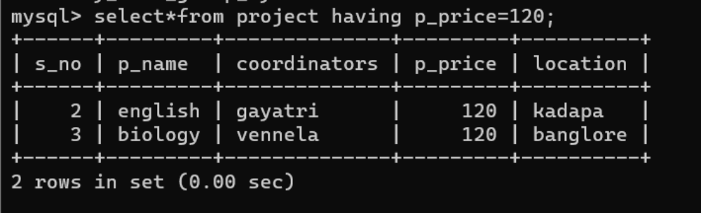

SELECT WITH ORDER BY COMMAND
